第四届“海外中国”论坛
第三号通知
泰国·曼谷，2018.8.24-26
“一带一路”砥砺前行，澜湄合作厚积薄发，“海外中国”论坛走出国门，落地“天使之城”泰国曼谷。
“海外中国”论坛是由中国河海大学举办的年度性国际论坛。“海外中国”是一种模式，是中国走出去的协同网络，是中外“政产学研金文”协同体，是跨境创新创业合作的平台。“海外中国”协同中外多主体、多要素，共商、共建、共享，携手共同成长。
本届论坛由中国河海大学、南京牛首山文旅集团、南京嘉智投资有限公司和泰国易三仓大学、安美德集团联合发起，主要由来自澜湄国家的政府部门、企业、高校、科研院所、金融机构、文化及媒体等代表参与，通过聚焦澜湄合作人才培养、泰国东部经济走廊建设、产业投资等领域，分享政策解读与机遇发现，书写跨文化交流、跨境合作、民心相通新篇章。
期待您的光临！
论坛时间

8月24-26日
论坛地点
- 泰国易三仓大学Suvarnabhumi校区
- Suvarnabhumi校区地址：88 Moo 8 Bang Na-Trad Km. 26 Bangsaothong, Samuthprakarn Thailand 10570
主办
中国河海大学
泰国易三仓大学
特别协办
中国南京牛首山文旅集团
泰国安美德集团
中国南京嘉智投资有限公司
承办
中国河海大学商学院
泰国易三仓大学商学院
中国河海大学世界水谷研究院
中国江苏嘉睿城建设管理有限公司
中国河海大学海外中心（老挝）
中国江苏省决策咨询基地（企业国际化发展）
协办
管理学会国际联盟（IFSAM）
东亚管理学会国际联盟（IFEAMA）
亚洲组织发展网络（AODN）
中国南京市商务局
中国江苏省金融业联合会海外江苏专委会
中国浙江乾冠网络安全研究院有限公司
中国深圳大学
日程
 | 8/24 周五 | 8/25 周六 | 8/26 周日
上午 |  | 8:00-9:00  报到注册 | 8:30-11:40  泰国安美德春武里工业区参观考察、交流互动
9:00-10:00 开幕式、签约仪式
10:00-10:30 茶歇、自由交流
10:30-12:00 主旨演讲
 |  | 12:00-13:20 会议午餐 | 11:40-13:00 安美德参观午餐
下午 | 14：00-17:30  报到注册  16:00-17:30  国际组织交流 | 13:30-15:00 平行论坛(上)  15:00-15:30 茶歇、自由交流  15:30-17:00 平行论坛(下)  17:00-18:00 闭幕式
 | 18:00-19:30  安美德迎宾晚餐 | 18:00-19:30 会议晚餐
平行论坛
- 论道澜湄：学者交流与教育合作
- 泰中合作：泰中经济文化发展交流会暨中国智慧城推介会
- 网络安全: 共建澜湄网络空间信息安全命运共同体
- 海外江苏·上海·广东：澜湄投资与制度建设
会务安排
- 论坛正式语言：英语
- 报到注册地点：
8月24日：Cher Chor酒店
8月25日：泰国易三仓大学Suvarnabhumi校区，Cathedral of Learning楼，一楼大厅
- 注册费
标准：一般参会人员 400美元或2700人民币, 在读学生减半
户名：中国河海大学
账号：4301011409001024513
开户行名称：南京工行宁海路支行
税务登记号：121000004660068699
转账备注内容：姓名+海外中国
保留转账凭证，大会注册现场核实；如需开具发票，请将开票信息发送至wwv@hhu.edu.cn；注册费用支付截止时间：8月24日
- 交通指引：从素万那普机场（BKK）乘坐出租车到泰国易三仓大学素万那普校区（Suvarnabhumi Campus）约40分钟（堵车风险较低）；从廊曼机场（DMK）乘坐出租车到泰国易三仓大学素万那普校区（Suvarnabhumi Campus）约60分钟（堵车风险较高）
- 推荐酒店：校区外Chor Cher宾馆（单人间/双标间约1200泰铢/晚，豪华套间约1700泰铢/晚）
酒店联系方式：
Tel：+ 66 021818855
Fax：021818859

Email：chorcher@chorcher.com

网址：www.chorcher.com
会议联络
- 中国
机构：河海大学商学院/世界水谷研究院
地址：中国江苏省南京市江宁区佛城西路8号，邮编：211100
电话：+86(025)68514380 传真：+86(025)68514918
网址：http://www.worldwatervalley.org/
E-mail：wwv@hhu.edu.cn 微信：请搜索公众号 世界水谷
联系人： 胡浩东 手机：+86 18705160873
朱苏鹭 手机：+86 18260050678
- 泰国
机构：易三仓大学商学院
地址：泰国曼谷邦卡皮华马克Ramkhamhaeng 24路泰国易三仓大学（华马克校区）592/3号，邮编：10240
电话：+66 (0)2-300-4543
网址：http://www.grad.au.edu/
E-mail：phdod@au.edu, rangsantrb@gmail.com
联系人：Ms. Seinn +66 (0)2-300-4543 (Ext: 3343)；
陈文钦 手机：0969863824
附件

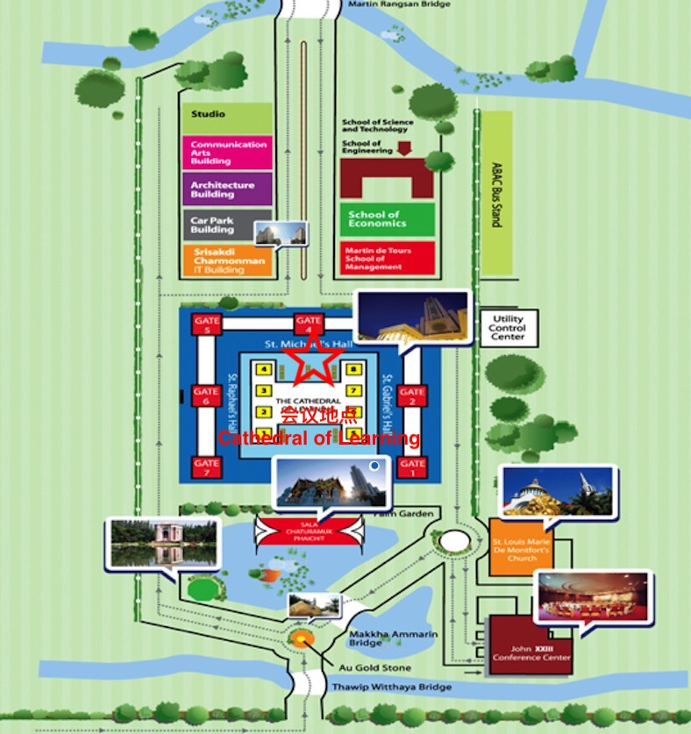
泰国易三仓大学 Suvarnabhumi 校区地图

The 4th “Overseas China” Forum
The 3rd Notification
Thailand • Bangkok, August 24th -26th 2018
In the era that “The Belt and Road” Initiative is forging ahead rapidly and Lancang-Mekong Cooperation is making remarkable progress, the “Overseas China” Forum will be held in Bangkok， Thailand which is known as the City of Angels.
The “Overseas China” Forum is an annual international conference organized by Hohai University, China. “Overseas China” is a pattern, a synergetic network for Chinese companies to go abroad, a synergetic entity of governments, industries, universities, research institutes, financing institutes, and cultural institutes, and a cross-border platform of innovation and entrepreneurship. “Overseas China” could synergize multiple subjects and elements to consult, contribute, share benefits, and grow up together.
The 4th “Overseas China” forum is jointly initiated by Hohai University, Nanjing Niushou Mountain Cultural Tourism Group Co. Ltd and Nanjing Jiazhi Investment Management Co. Ltd. from China, Assumption University and Amata Corporation PCL from Thailand. Representatives from government sectors, enterprises, academia, financial institutions, culture and media organizations from Lancang-Mekong countries will converge together. This forum focuses on topics of talents cultivation in Lancang-Mekong cooperation, construction of Eastern Economic Corridor in Thailand, city-industry integration, industrial investment, and so on. Interpretation of policy as well as discoveries of opportunities will be shared on the forum. This activity aims at writing a new chapter of cross-cultural communication, cross-border cooperation and people-to-people bonds.
We sincerely welcome participants from all around the world to join us.

Time

August 24th -26th , 2018

Location
- Suvarnabhumi Campus, Assumption University, Bangkok, Thailand
- Campus Address：88Moo 8 Bang Na-Trad Km. 26 Bangsaothong, Samuthprakarn Thailand 10570

Hosts

Hohai University，China
Assumption University，Thailand

Special Co-organizers
Nanjing Niushou Mountain Cultural Tourism Group Co. Ltd., China
Amata Corporation PCL, Thailand
Nanjing Jiazhi Investment Management Co. Ltd., China

Organizers
Business School of Hohai University, China
Graduate School of Business, Assumption University, Thailand
World Water Valley Institute of Hohai University, China
Jiangsu Graycity Engineering Management Co.Ltd., China
Overseas Center of Hohai University (Laos), China
Jiangsu Decision-making Consultation Base (Enterprise Internationalization Development), China

Co-organizers
International Federation of Scholarly Associations of Management (IFSAM)
International Federation of East Asian Management Associations (IFEAMA)
Asia OD Network（AODN）
Nanjing Municipal Bureau of Commerce, China
Overseas Professional Committee of Jiangsu Financial Federation, China
Zhejiang QianGuan Information Security Institute, China

Shenzhen University, China

Program
August 24th Friday | August 25th Saturday | August 26th Sunday
 | 8:00-9:00 Registration | 8:30-11:40  Visit Amata Industrial Park in Chonburi
9:00-10:00 Opening Ceremony
Agreement Signing
10:00-10:30 Tea Break
10:30-12:00 Keynote Speech
 | 12:00-13:20 Lunch | 11:40-13:00  Lunch at Amata
14:00-17:30  Registration  16:00-17:30  International Organizations Communicate | 13:30-15:00 Parallel Forum I  15:00-15:30 Tea Break  15:30-17:00 Parallel Forum II  17:00-18:00 Closing Ceremony
18:00-19:30  Welcome Dinner by Amata | 18:00-19:30 Dinner

Subjects of Parallel Forums
- Academic Sharing and Education Cooperation in Lancang-Mekon Region
- Thailand and China Economic &Cultural Exchange：China Smart City Promotion Seminar
- Zhejiang Qianguan: Network Security and Trade Secret Protection——Building a Community of Shared future of Information Security in Lancang-Mekong Cyberspace
- Overseas Jiangsu·Shanghai·Guangdong: Investment and Institution Construction in Lancang-Mekong River Region

Registration & Fee
- Official language：English
- Registration Venue:
August 24th ：Cher Chor Hotel
August 25th ：First floor lobby, Cathedral of Learning, Assumption University, Suvarnabhumi Campus
- Registration fee: 400 USD (2700 RMB) for regular participant, 200 USD (1350 RMB) for student
- Payment

Account title：Hohai University

Remittances account：4301011409001024513
Name of bank：Nanjing Industrial and Commercial Bank Ninghai Road Branch

Tax registration number：121000004660068699

Notes for transfer：Name+ Overseas China
Please retain the transfer voucher. It will be verified at the conference registration site.
Hohai university can issue invoices for you if you need. Please send the invoice information to wwv@hhu.edu.cn.
Registration fee payment deadline: August 24th
- Transportation
Suvarnabhumi Airport (BKK) to Assumption University Suvarnabhumi Campus: about 40 minutes by taxi
Don Mueang Airport (DMK) to Assumption University Suvarnabhumi Campus: about 60 Minutes by taxi
- Recommended Accommodation：Cho Cher Hotel (1200 THB/night for single/double rooms, 1700 THB /night for deluxe suites)

Hotel contact：

Tel：+ 66 021818855
Fax：021818859

Email：chorcher@chorcher.com
Website:www.chorcher.com

Contact us
- China
Organizers: World Water Valley Institute, Business School
Address: No.8 Focheng West Road, Jiangning District, Nanjing, Jiangsu, China, Post code: 211100
Tel: +86（025）68514380
Fax: +86（025）68514918

Website: http://www.worldwatervalley.org/

E-mail: wwv@hhu.edu.cn

Contacts: Mr. Hu +86 18705160873, Ms. Zhu+86 18260050678
- Thailand
Organizers: Office of Graduate Studies
Address: Assumption University (Huamak Campus), 592/3, Ramkhamhaeng 24 Road, Huamak, Bangkapi, Bangkok, Thailand, Post code: 10240
Tel: +66 (0)2-300-4543

Website: http://www.grad.au.edu/

E-mail: phdod@au.edu, rangsantrb@gmail.com
Contacts: Ms. Seinn +66 (0)2-300-4543 (Ext: 3343);
Ms. Chen + 66 0969863824
Attachments

Map of Assumption University Suvarnabhumi Campus

